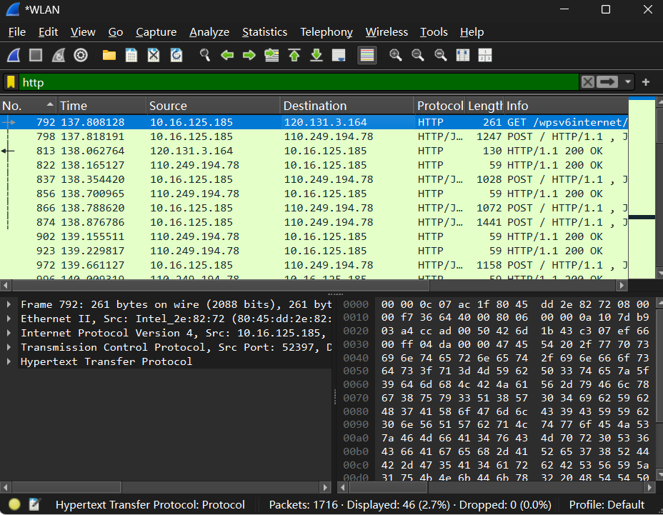

1. List 3 different protocols that appear in the protocol column in the unfiltered

packet-listing window in step 7 above.

TCP, ARP,DNS

2. How long did it take from when the HTTP GET message was sent until the HTTP

OK reply was received? (By default, the value of the Time column in the packet

listing window is the amount of time, in seconds, since Wireshark tracing began.

To display the Time field in time-of-day format, select the Wireshark *View* pull

down menu, then select Time *Display Format*, then select *Time-of-day*.)

No. 792 http get: 137.808128s

No. 813 http ok: 138.062764s

138.062764 - 137.808128 = 0.254636s

3. What is the Internet address of the gaia.cs.umass.edu (also known as www

net.cs.umass.edu)? What is the Internet address of your computer?

Internet address of the gaia.cs.umass.edu:

120.131.3.164

Internet address of my computer:

10.16.125.185

4. Print the two HTTP messages (GET and OK) referred to in question 2 above. To

do so, select *Print* from the Wireshark *File* command menu, and select the

“*Selected Packet Only”* and *“Print as displayed”* radial buttons, and then click

OK.

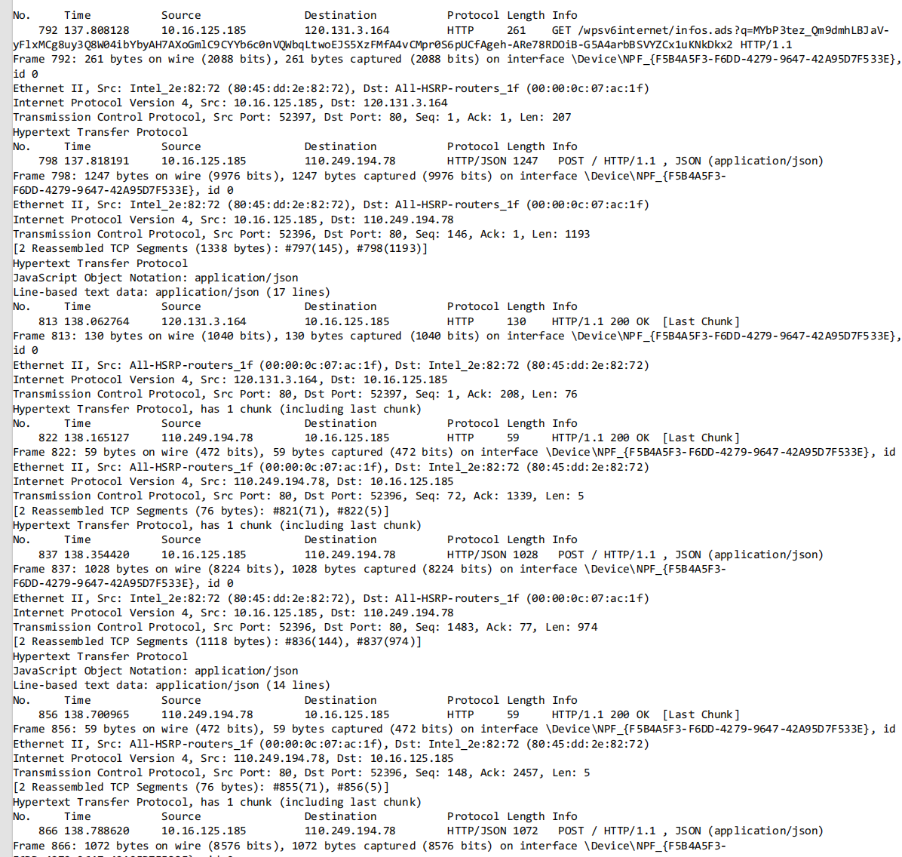

Phase 2

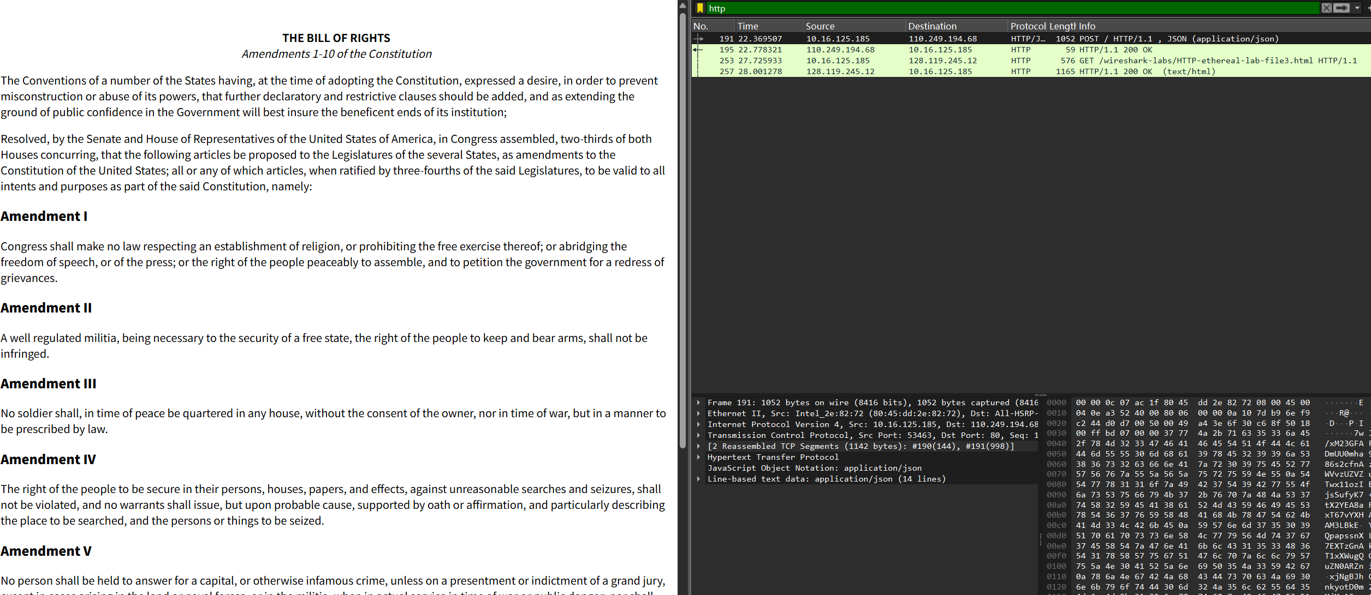

No.253 http get

No.257 http ok

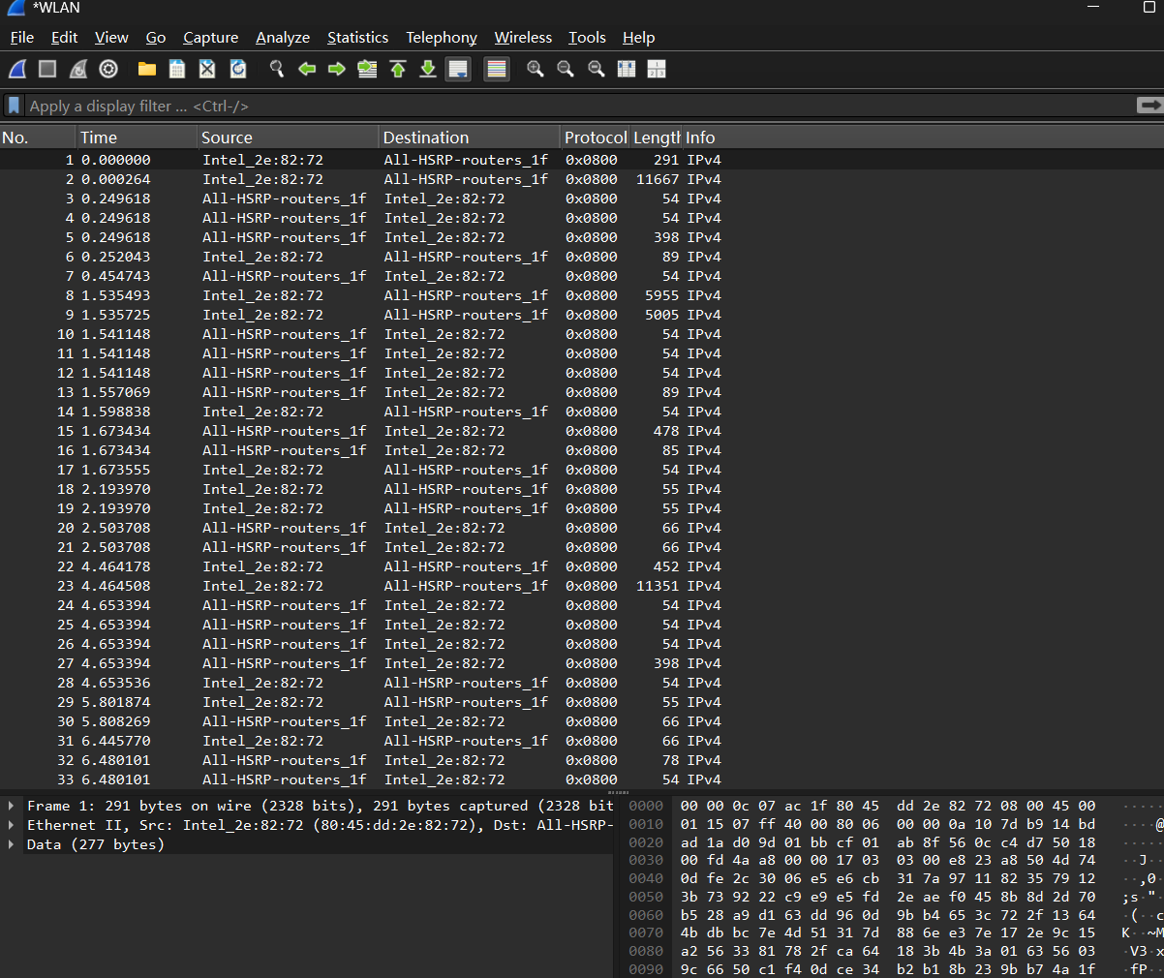

Uncheck ip box